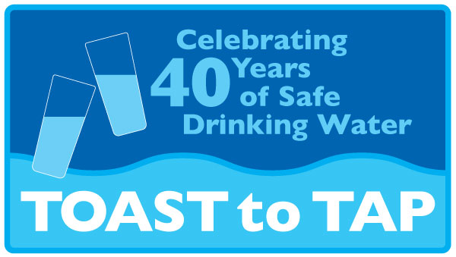

**Press Release**  Nicole Condon

October 2, 2014 Water Communications Coordinator

DC Water

202-787-2214 (O)

202-213-9568 (C)

nicole.condon@dcwater.com

“Toast to Tap” Event to Celebrate Value of Safe Drinking Water for Our Health and Local Economy

* ***Washington area celebrates the 40th anniversary of the Safe Drinking Water Act –***

October 2, 2014— Regional water utilities, Metropolitan Washington Council of Governments, national water organizations and the U.S. Environmental Protection Agency organized a **“Toast to Tap”** celebration on Thursday, October 2, 2014 to commemorate the 40th anniversary of the Safe Drinking Water Act. The Act was passed by Congress in 1974 to protect public health by regulating drinking water supplies. Amended in 1986 and 1996, the law establishes standards for drinking water quality and authorizes the Environmental Protection Agency to coordinate with states, localities and water suppliers to ensure the safe delivery of tap water and the protection of drinking water sources. Hosted in the Park at CityCenter in Northwest DC, the event brought togethermembers of the water community and local businesses to highlight the value of safe water to the metro region.

“Over 40 years ago, there was a dramatic shift in the way that Americans related to the environment,” said DC Water General Manager George S. Hawkins. “Recognizing the need to protect public health through safer drinking water supplies, advocates led the way for landmark legislation that regulates water systems and ensures that the public is informed about their drinking water.”

“We’ve made incredible progress in improving the safety of drinking water during the past 40 years. Safe and reliable drinking water is central to our lives, and the important work that the water sector does to protect the health of American people each and every day is vital to our local economies,” added Ken Kopocis, Deputy Assistant Administrator for the U.S. Environmental Protection Agency’s Office of Water.

Today’s interactive event featured games, giveaways and hands-on activities such as a water taste test, water wheel of fortune, and free water poured from the taps of a mobile water bar. Officials from the EPA led a “toast to tap water” with reusable water bottles and local tap water. Event organizers included: Regional water utilities, Metropolitan Washington Council of Governments, American Water Works Association, U.S. Environmental Protection Agency, and the Association of State Drinking Water Administrators.