EPA’S FLOOD RESILIENCE TOOLS

Flood Resilience: A Basic Guide for Water and Wastewater Utilities

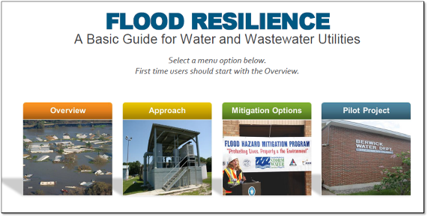
Easy-to-use tool that includes worksheets,
instructional videos, and flood maps. Through a 4-step process, utilities can understand their flood risks and identify mitigation options.
Watch Video: Guide Overview

Flooding Incident Action Checklist

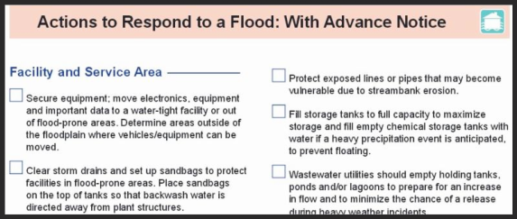
"Rip and run" with this checklist to
understand the potential impacts and what actions can be taken immediately before, during, and after a flood.

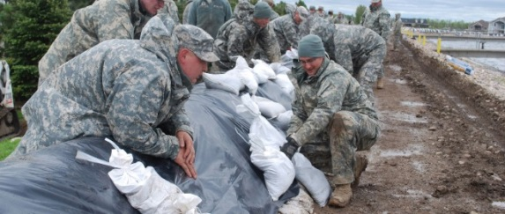
Extras:
- Berwick, Maine Pilot: Learn how EPA helped a small water utility Take Steps to Build Flood Resilience
- In EPA's Blog Post "Surviving the Flood", an EPA employee recounts his personal flooding experience as a child, and how it relates to flooding hazards that water utilities face today.
- NWS general Flood Safety Information Home Page

