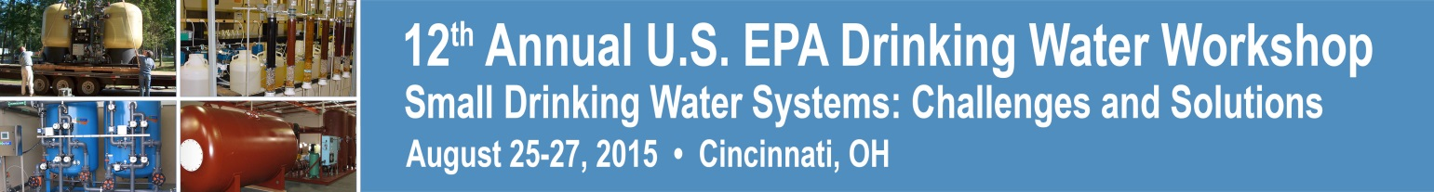

Overview
Approximately 94% of drinking water systems in the United States are “small systems” serving 10,000 or fewer customers. Because of their small size, many of these small systems have technical, operational, managerial and financial challenges in providing safe drinking water to their consumers. To aid them in overcoming the many challenges they face, small systems rely on the technical assistance and advice provided by their state and local officials.

To support the efforts of state and local officials to assist small systems, the U.S. EPA has conducted a yearly workshop for the past 11 years to provide timely information on a variety of drinking water topics including drinking water regulations, compliance issues, emerging contaminants, and treatment technologies.

EPA’s first workshop was held in 2004 by invitation only. It was designed for state staff working with small communities to install arsenic treatment technologies. At the encouragement of state agencies, the annual workshop was open to the public in 2008 and has been expanded to include the many topics of concern to small drinking water systems.

Workshop Overview
The 12th annual workshop will provide in-depth training and information on various solutions and strategies for handling small systems problems and compliance challenges. The workshop offers multiple sessions and activities:
- Opening session
- 9 technical sessions
- 6 breakout groups
- Wrap-up session
- Optional tours of EPA’s research facilities

Who Should Attend?
The workshop is primarily designed for state personnel responsible for drinking water regulations compliance and treatment technologies permitting. However, past workshops have attracted attendees from numerous other disciplines:
- Design engineers
- Technical assistance providers
- Consulting firms
- Equipment manufacturers
- Academia
- Small systems owners
- Certified water systems operators

Past workshops have attracted up to 250 participants with as many as 80 state personnel representing over 40 state drinking water programs.

Agenda and Topics
The workshop will begin at 8:30 a.m. on Tuesday, August 25, 2015, and is anticipated to conclude at approximately 11:30 a.m. on Thursday, August 27, 2015.

The following topics will be included this year:
- Lead and Copper Rule
- Revised Total Coliform Rule (RTCR)
- Cyanontoxins
- Legionella
- Fluoridation
- Disinfection and DBPs
- Small Systems Treatment
- Distribution System Issues
- Emerging Contaminants
- Other Small Systems Information

A preliminary workshop agenda will be posted on this page once available.

Speakers
Speakers will include EPA staff, state personnel, engineering consultants, and university professors.

Sponsors
- EPA’s Office of Research and Development/National Risk Management Research Laboratory
- EPA’s Office of Water/Office of Ground Water and Drinking Water
- Association of State Drinking Water Administrators

Workshop Registration
The workshop is free to the public, so there is no registration fee to attend. Online registration will open in late June 2015. To be added to the workshop email distribution list, please email Alina Martin (Leidos, Inc.) at martinali@leidos.com.

Workshop Location
Hyatt Regency Cincinnati
151 West Fifth Street
Cincinnati, OH 45202
Tel: 513-579-1234
Fax: 513-354-4299
www.cincinnati.hyatt.com

Lodging
Information on lodging options and how to book a room within the group block at the Hyatt Regency Cincinnati will be posted on this website in mid-June.

Inquiries
Inquiries about the workshop or lodging may be directed to Alina Martin of Leidos, Inc. (EPA contractor) at (858) 432-3750 or martinali@leidos.com.

