Case Study: Using the Clean Water State Revolving Fund for Source Water Protection
The Rhode Island Experience
The Rhode Island Department of Environmental Management, in partnership with the Rhode Island Infrastructure Bank, has administered three Clean Water State Revolving Fund loans for source water protection. Source water protection was achieved by purchasing land within critical drinking water watersheds throughout the state. The loans were awarded to the Town of Middletown, and to the Providence Water Supply Board.
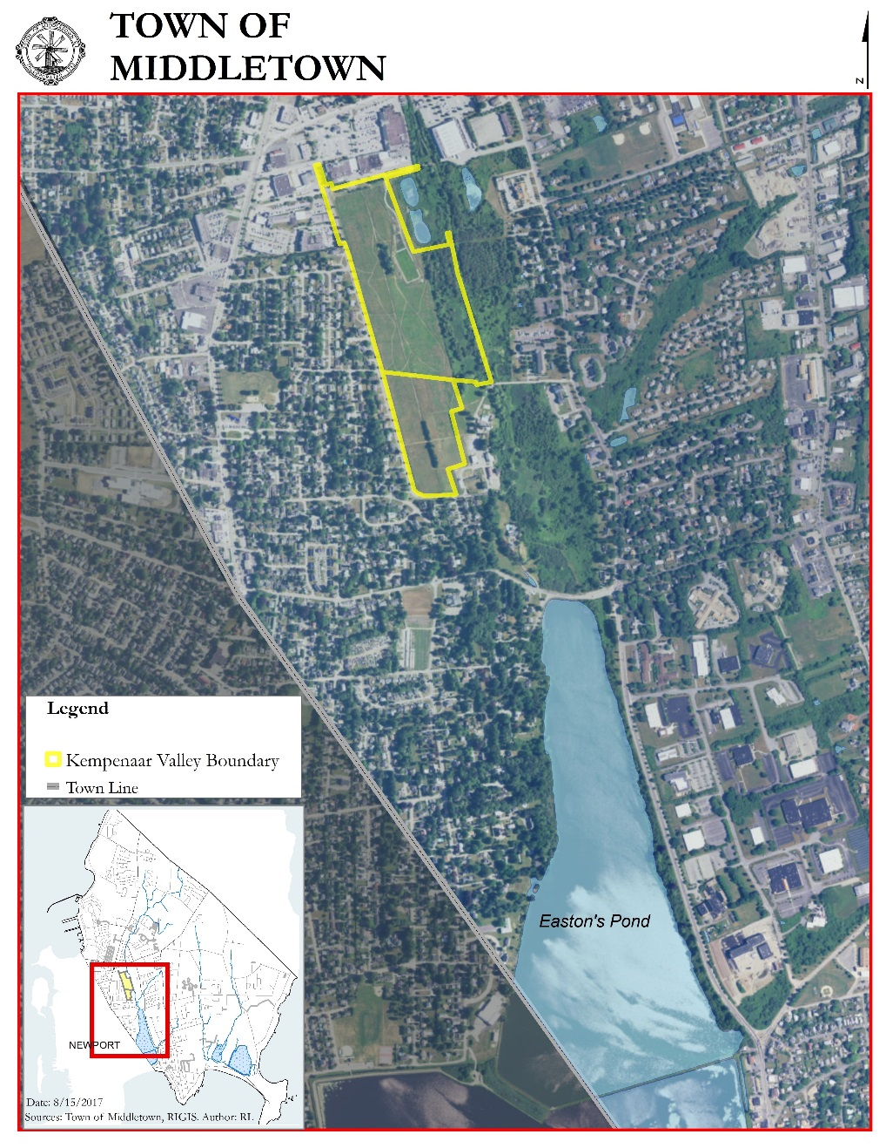
Middletown, Rhode Island Land Acquisition:
The first CWSRF loan in Rhode Island for Source Water Protection was made in 2004 ($1 Million) and assisted with Middletown’s purchase of the Kempenaar Valley property. In addition to CWSRF funding, grants from RIDEM, the Aquidneck Island Land Trust, and the City of Newport’s Water Protection Fund were utilized to purchase the property.
The Kempenaar Valley parcel contains a segment of Bailey’s Brook, which is the major water source flowing into North Easton’s Pond reservoir, which is part of the drinking water supply for the City of Newport. The property was previously used as a nursery, and was purchased in efforts to protect the drinking water supply and conserve open space. Bailey’s Brook is impaired for bacteria and nutrients, and the TMDL notes that the Brook is a source of nutrient loading to North Easton’s Pond. The Pond is impaired for high levels of phosphorus. These impairments can be largely attributed to stormwater runoff, as the watershed is 32% impervious cover.
Figure 1: Kempenaar Valley Property, GIS Map Provided by Middletown, RI Planning Department
Conserving the Kempenaar Valley property allowed Newport Water to partner with the RI Department of Transportation in 2010 in order to create a gravel wet vegetative system on the site. The treatment system is designed to receive stormwater from 28 acres of impervious surface located in the urbanized West Main Road and High Street watersheds. This project is expected to reduce phosphorus loading by 56% and bacterial loading by 85%.

Providence Water Supply Board Land Acquisition:
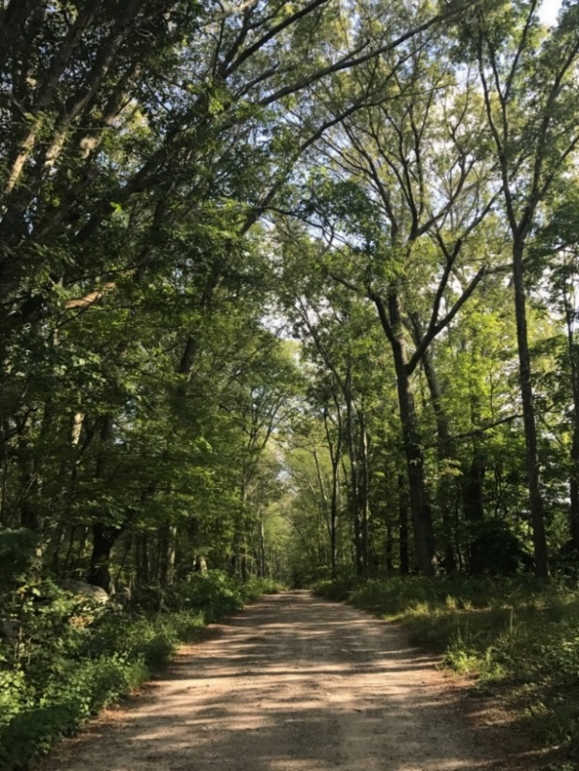
The Providence Water Supply Board (PWSB) received CWSRF loans in 2012 ($3 Million) and 2013 ($4.2 Million) in order to purchase land throughout the Scituate Reservoir Watershed. The Scituate Reservoir complex (consisting of the Scituate, Moswansicut, Ponaganset, Barden, Westconnaug, and Regulating Reservoirs) is the largest drinking water supply in Rhode Island and serves approximately 60% of the state.
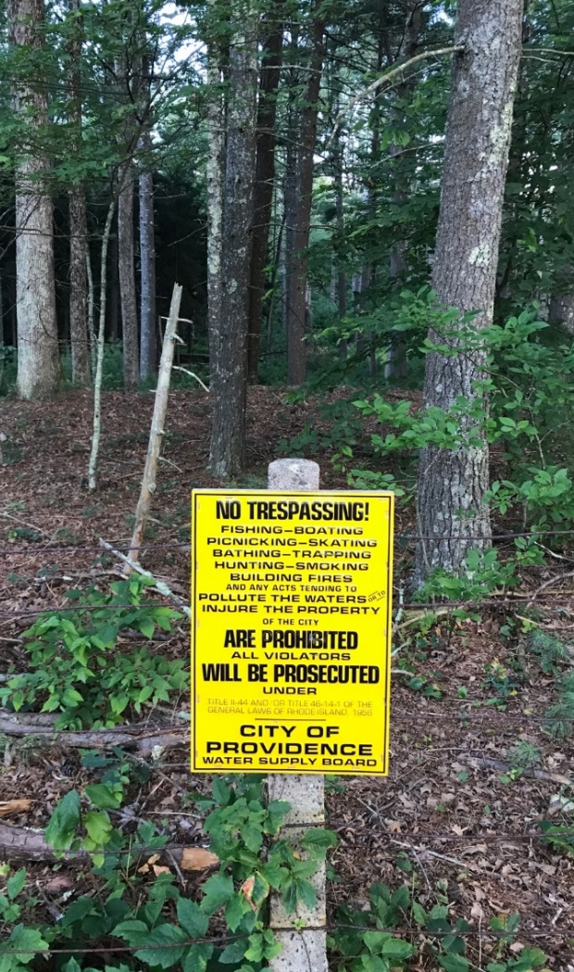
Land use throughout the watershed is currently assessed at 10% low-impact development, a level at which impacts from stormwater runoff are typically not detrimental to overall water quality. By purchasing land throughout the watershed the PWSB can ensure that maximum buildout in the watershed is limited by preserving forested land. Compared to other major water suppliers in Southern New England, Providence Water ranks below average in categories pertaining to watershed protection including land ownership and percent of watershed which is protected. In 2008 the PWSB owned 28% of the watershed land, and 32% of the land overall was protected. On average, major water suppliers owned 30% of the watershed, and 49% of the watershed was protected.
Figure 2: Forested property that was purchased by the PWSB using CWSRF funds in Glocester, RI

The “Scituate Reservoir Source Water Assessment”, states that in the future it is possible for the watershed to become 30% low-impact development, with some areas such as the Moswansicut Reservoir experiencing even higher levels of development (URI Cooperative Extension, 2003). The development could lead to the loss of nearly half of the forested acreage throughout the watershed and would have significant negative water quality impacts. Purchasing properties within the watershed can ensure that critical forested areas preserved and water quality is protected.
Both PWSB Loans were funded as part of the Green Project Reserve (GPR) requirement of the US EPA Clean Water SRF capitalization grants. The RI CWSRF program links GPR projects with additional subsidization (another capitalization grant requirement) in the form of principal forgiveness. Due to this linkage, PWSB realized over 10% ($804,573) of its two loans forgiven.
Figure 3: “No Trespassing” sign located on preserved land owned by the PWSB
For more information, contact: Jay Manning, Principal Engineer, Office of Water Resources, Rhode Island Department of Environmental Management, at (401) 222-4700, x7254 or Jay.manning@dem.ri.gov.

