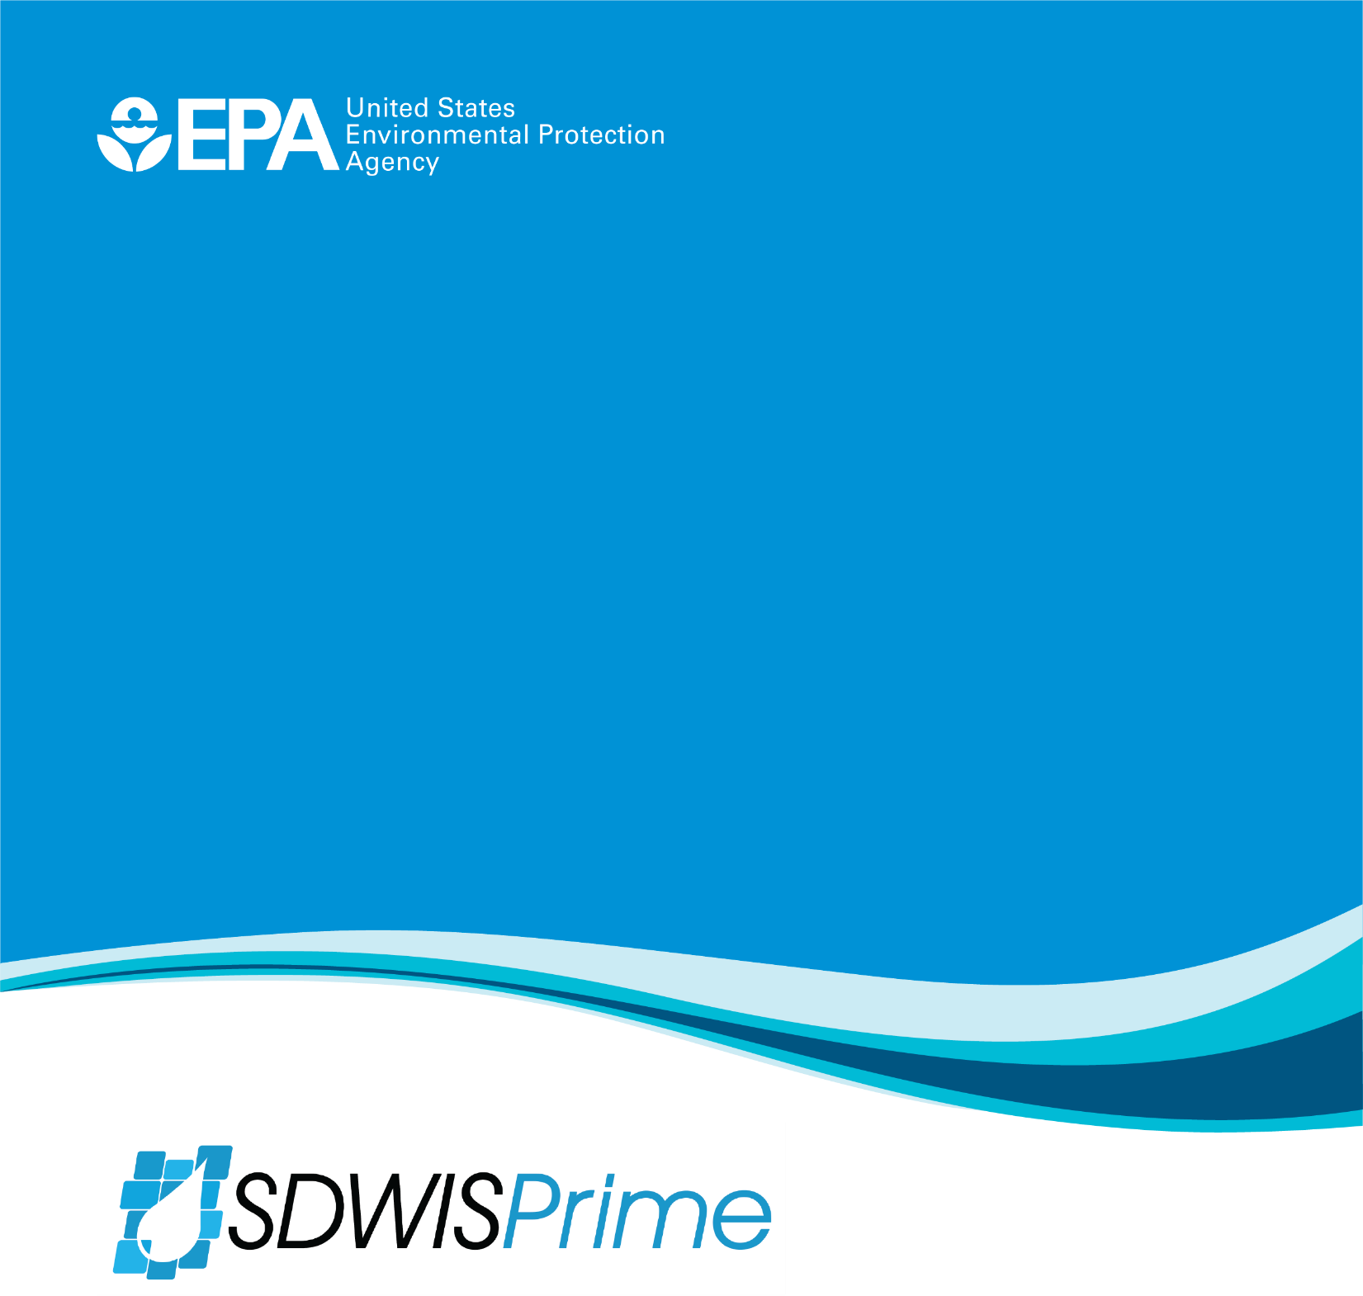

SDWIS CY19R1 Master Test Case Instructions
Version 0.1

Version 0.1
April 24, 2019
EPA_OW_SDWIS_Master Test Case Instructions_CY19R1v0.1_DRAFT.docx

Prepared by: Attain, LLC

Table of Contents
1 Purpose 1
2 Test Case Instructions 1
2.1 Test Case # 32 - Global M/R Compliance Determination (RTCR, NO3, and IOC) 2
2.2 Test Case 33. RTCR E. coli MCL Violations 5
2.3 Test Case # 34 - Validate Global Set of Violations, Process candidate violations for multiple Rules and water systems 8
2.4 Test Case # 35 - DBP M/R Sampling Point Violation 10
2.5 Test Case # 37 - DBP M/R Violation, Every 90 Days Failure 12
2.6 Test Case # 39 - Failure to Address a GWR Deficiency 16
2.7 Test Case # 40 - Display Originating Result for RP, TG, and CO MS 20

SDWIS CY19R1 Master Test Case Instructions

Purpose
The purpose of the SDWIS CY19R1 Master Test Case Instructions is to provide community testers with the instructions to conduct testing for the integration of BRE into the SDWIS/Prime application and for the new features developed to support that integration.

Test Case Instructions
The SDWIS CY19R1 Master Test Case Instructions document contains guidance for the following test cases:
- Test Case #32 Global M/R Compliance Determination for RTCR, NO3, and IOC
- Test Case #33 RTCR E. coli MCL Violations
- Test Case #34 Validate Global Set of Violations, Process candidate violations for multiple Rules and water systems
- Test Case #35 Disinfection Byproducts (DBP) Monitoring/Reporting (M/R) Sampling Point Violation
- Test Case #37 Disinfection Byproducts (DBP) HAA5 and TTHM M/R Violations, Every 90 Days Failure
- Test Case #39 Failure to Address a GWR Deficiency
- Test Case #40 Display Originating Result for Repeat (RP), Triggered (TG), and Confirmation (CO) Monitoring Schedules

Test Case # 32 - Global M/R Compliance Determination (RTCR, NO3, and IOC)

Test Description
In this test case, a user runs monitoring and reporting (M/R) compliance on select water systems in a primacy agency for several combinations of Rules (e.g., RTCR) and periods (e.g., June 2018). The application generates the appropriate candidate monitoring violations for the user to validate. Additionally, the test case includes creating a Regulating Agency and assigning several water systems to it.

Test Steps and Outcomes
- Create a Regulating Agency using the following steps.
- Open the Legal Entity module and click on Create.
- On the Basic Information form:
- Select "Government Agency" in the Category dropdown
- Select "Active" in the Status dropdown
- Enter any memorable name in the Name field
- Check the Is Regulating Agency checkbox, and
- Click on the save icon.
Expected Outcome:
- You should receive the message "Basic Information was saved successfully." at the top of the Basic Information form.
- Select seven water systems that meet the criteria below. Note that you should perform Steps 2, 3, and 4 together for each PWS.
- Two active transient, non-community water systems (TNC), one of which operates seasonally.
  - Note that, to select a seasonal TNC, you need to open the water system record and look at the Service Begin and Service End columns under Population Served.
- Two active non-transient, non-community water systems (NTNC), and
- Three active community water systems (CWS) with ground water as their Federal Primary Source Type.
- For each water system, open the Basic Information form and associate it to the Regulating Agency created in Step 1. When you click the save icon, in addition to associating it to the regulating agency, the BRE will be triggered to determine appropriate monitoring schedules for the water system.
Expected Outcomes:
- The PWS should be associated to the Regulating Agency (confirmed by this message at the top of the Basic Information form, "Basic Information was saved successfully" and the regulating agency displayed in the Regulating Agency field).
- The BRE should create several candidate Monitoring Schedules.
    - For all the water systems, there should be candidate Monitoring Schedules for:
      - RTCR routine monitoring
      - Nitrite routine monitoring
      - Nitrate routine monitoring
    - For the NTNC and CWS, there should additionally be candidate Monitoring Schedules for:
      - LCR
      - IOC
      - VOC
      - SOC
    - For the CWS, there should additionally be a candidate Monitoring Schedule for:
      - RADR
    - Both the NTNC and CWS may have other candidate Monitoring Schedules including one or more for DDBP and SWTR.

- Set the Frequency Start Date to 01/01/2018 for the RTCR monitoring schedule and validate it.

Set the Frequency Start Date for at least one of the nitrate (NO3) monitoring schedules as follows and then validate it/them:
- For annual schedules, set the Frequency Start Date to 01/01/2017
- For quarterly schedules, set the Frequency Start Date to 01/01/2018

Set the Frequency Start Date for at least one of the inorganic chemicals (IOC) monitoring schedules as follows and then validate it/them:
- For triennial schedules, set the Frequency Start Date to 01/01/2015
- For annual schedules, set the Frequency Start Date to 01/01/2017

- Use the global Ad Hoc M/R Compliance Determination feature to run M/R compliance for three Rules using the following combinations. To run global ad hoc M/R Compliance, select the Compliance Determination module (on the left most pane) and click on the Compliance Determination link to expand it.
For each run, select the Regulating Agency created in Step 1 and use the Rule/Analyte Group used to create the RTCR, nitrate, and inorganic chemicals monitoring schedules.
Rule | Period Start | Period End
RTCR | 01/01/2018 | 03/31/2018
NO3 | 01/01/2017 | 12/31/2017
IOC | 01/01/2015 | 12/31/2017

Outcomes for this step are viewed in the next step.
- Open the global Violations component and filter the list as follows:
- Violation: 3A-Routine Monitoring Violation
- Status: Candidate
- From Status Date: the date you did step 5
- To Status Date: the date you did step 5

Expected Outcomes:
- "Candidate" violations for "3A-Routine Monitoring Violation" with a Status Date equal to today's date and one of the following combinations of Compliance Periods should be displayed:
Compliance Period Begin Date | Compliance Period End Date
01/01/2018 | 03/31/2018
01/01/2018 | 01/31/2018
02/01/2018 | 02/28/2018
03/01/2018 | 03/31/2018

- For the four non-community water systems selected in Step 2, there should either be one candidate 3A for 01/01/2018 - 03/31/2018 or three candidate 3A, one for January, February, and March 2018 respectively for each (unless the seasonal TNC selected is not open at all in the first quarter of the year).
- For the three community water systems selected in Step 2, there should be three candidate 3A, one for January, February, and March 2018 for each.
- Note that there may also be some candidate Repeat monitoring violations.
- Remain in (or open) the global Violations component and filter the list as follows:
- Violation: 03-MONITORING, ROUTINE
- Status: Candidate
- From Status Date: the date you did step 5
- To Status Date: the date you did step 5
Expected Outcomes:
- "Candidate" violations for "03-MONITORING, ROUTINE" with a Status Date equal to the date you did step 5 and one of the following combinations of Compliance Periods should be displayed for Rule/Analyte Groups: "NO3-NPDWR" and "IOC-NPDWR" for the PWSs selected in Step 2 and the monitoring schedules validated in Step 4:
Compliance Period Begin Date | Compliance Period End Date
01/01/2017 | 12/31/2017
01/01/2015 | 12/31/2017

End of test

Test Case 33. RTCR E. coli MCL Violations

Test Description
Three community water systems incur a 1A - E. Coli MCL violations for three different reasons, one for each of the criteria defined in 141.860(a)(2) - (4) as follows:
(2) The system has a total coliform-positive repeat sample following an E. Coli-positive routine sample.
(3) The system fails to take all required repeat samples following an E. Coli-positive routine sample.
(4) The system fails to test for E. Coli when any repeat sample tests positive for total coliform.
Note that the condition under 141.860(a)(1) is tested in Test Case 7b.

Test Steps and Outcomes
- Select three community water systems (CWS), the first two with populations of 1,000 or fewer people and the third with a population of more than 33,001.
- For each selected CWS, enter a routine RTCR monitoring schedule for the CWS’s distribution system with a Frequency Start Date of 1/1/2018. For the first two, enter a monitoring schedule that calls for 1 routine per month. For the third one, enter a monitoring schedule that calls for the appropriate number of routine samples each month based on that CWS population served; see the following table.
Population served | Minimum number of  samples per month
1,000 or fewer | 1
33,001 to 41,000 | 40
41,001 to 50,000 | 50
50,001 to 59,000 | 60
59,001 to 70,000 | 70
70,001 to 83,000 | 80
83,001 to 96,000 | 90
96,001 to 130,000 | 100

- Enter the RTCR routine samples and results in the following table, collected in the distribution system used when creating the RTCR monitoring schedules in Step 2. You can use one or more laboratories for the samples.

Violation  Criteria | Water System | Sample Type | Sample Date | 3100- Coliform | 3014-  E. coli | Analysis End Date
(2) | CWS # 1 | Routine | 7/16/2018 | Present | Present | 7/18/2018
(3) | CWS # 2 | Routine | 7/16/2018 | Present | Present | 7/18/2018
(4) | CWS # 3 | Routine | 7/16/2018 | Present | Absent | 7/18/2018

Expected Outcomes:
- The total coliform routine result should be associated to each of the RTCR routine monitoring schedules entered in Step 2 for the July 2018 period and displayed on the Monitoring Schedule Sample Result window. The E. coli result should also be displayed with the total coliform result.
- There should be a candidate repeat monitoring schedule calling for 3 samples with a start date of 7/16/2018 and an end date of 7/19/2018 for all three selected water systems.

- Validate all three candidate RTCR repeat monitoring schedules.
- Enter the RTCR repeat samples and results from the following table, collected in the distribution system you used when creating the RTCR monitoring schedules in Step 2. You need to select the routine entered in Step 3 as the "Original Sample" for each one. You can use one or more laboratories for the samples. Note that CWS # 2 does not collect any repeat samples.

Violation  Criteria | Water System | Sample Type | Sample Date | 3100- Coliform | 3014-  E. coli | Analysis End Date
(2) | CWS # 1 | Repeat | 7/19/2018 | Present | Absent | 7/23/2018
 |  | Repeat | 7/19/2018 | Absent | - | 7/23/2018
 |  | Repeat | 7/19/2018 | Absent | - | 7/23/2018
(4) | CWS # 3 | Repeat | 7/19/2018 | Present | - | 7/23/2018
 |  | Repeat | 7/19/2018 | Absent | - | 7/23/2018
 |  | Repeat | 7/19/2018 | Absent | - | 7/23/2018

Expected Outcomes:
- There should be a candidate 1A E. Coli MCL violation for CWS # 1.
- The first three repeat total coliform results should be associated to the RTCR repeat monitoring schedule for CWS # 1.
- The second three repeat total coliform results should be associated to the RTCR repeat monitoring schedule for CWS # 3.
- There should be a candidate repeat monitoring schedule calling for 3 samples for CWS # 3 with a start date of 7/19/2018 and an end date of 7/24/2018.

- Run RTCR M&R Compliance for each of the three CWS for the month of July 2018.
Expected Outcomes:
- There should be a candidate 1A E. Coli MCL violation for CWS # 2.
- There should be a candidate 1A E. Coli MCL violation for CWS # 3.
- There should also be a candidate 3A Minor (i.e., Major Violation Indicator = No) Monitoring violation for each CWS if the RTCR routine monitoring schedule calls for more than 1 routine per month.

End of test

Test Case # 34 - Validate Global Set of Violations, Process candidate violations for multiple Rules and water systems

Test Description
In this test case, a user validates a set of candidate violations with different violation codes, for different Rules, and for more than one PWS.
This test case builds on Test Case 32 and so needs to be run after that test case. Test Case # 32 produces candidate M&R violations for a select set of PWS.

Test Steps and Outcomes
- Open the global Violations component and filter the list as follows:
- Violation: 3A-Routine Monitoring Violation
- Status: Candidate
- From Status Date: the date M/R compliance was run in Test Case 32
- To Status Date: the date M/R compliance was run in Test Case 32
Expected Outcomes:
  - Only "Candidate" violations for "3A-Routine Monitoring Violation" with a Status Date equal to the date Test Case 32 was run and one of the following combinations of Compliance Periods should be displayed:
Compliance Period Begin Date | Compliance Period End Date
04/01/2018 | 06/30/2018
04/01/2018 | 04/30/2018
05/01/2018 | 05/31/2018
06/01/2018 | 06/30/2018

  - For the four non-community water systems selected in Step 1 of Test Case 32, there should either be one candidate 3A for 04/01/2018 - 06/30/2018 or three candidate 3A, one for April, May, and June 2018 respectively for each.

  - For the three community water systems selected in Step 1 of Test Case 32, there should be three candidate 3A, one for April, May, and June 2018 respectively for each.
- Validate all the candidate 3A violations for the PWS selected in Step 1 of Test Case # 32. Be sure to change the Issue Date to 30 days after the Compliance Period End Date for each violation (to do this, you need to select subsets of violations where all of them validated together have the same Compliance Period End Date).
Expected Outcomes:
  - All of the violations should be validated.
  - A Tier 3 PN requirement should be created for each one. To check, select "Scheduled Activities" in the task picker after validating the violation or use the global Scheduled Activities module to review the Tier 3 public notifications.
- Open/remain in the global Violations component and filter the list as follows:
  - Violation: 03-MONITORING, ROUTINE
  - Status: Candidate
  - From Status Date: the date M/R compliance was run in Test Case 32
  - To Status Date: the date M/R compliance was run in Test Case 32

Expected Outcomes:
  - Only "Candidate" violations for "03-MONITORING, ROUTINE" with a Status Date equal to the date M/R compliance was run in Test Case 32 and one of the following combinations of Compliance Periods should be displayed for Rule/Analyte Groups: "NO3-NPDWR" and "IOC-NPDWR" for the PWS selected and monitoring schedules validated in Test Case 32:

Compliance Period Begin Date | Compliance Period End Date
01/01/2017 | 12/31/2017
01/01/2015 | 12/31/2017

- Validate all the candidate "03-MONITORING, ROUTINE" violations for the PWS selected in Step 1. Be sure to change the Issue Date to 30 days after the Compliance Period End Date for each violation (to do this, you need to select subsets of violations where all of them validated together have the same Compliance Period End Date).

Expected Outcomes:
  - All of the violations should be validated
  - A Tier 3 PN requirement should be created for each violation.

End of test

Test Case # 35 - DBP M/R Sampling Point Violation

Test Description
This test case checks that monitoring and reporting compliance is done at the sampling point level when sampling points are included in a monitoring schedule. It tests this capability for a disinfection byproducts (DBPs TTHM and HAA5) monitoring schedule.

Test Steps and Outcomes
- Select a Subpart H, community water system (CWS) with a primary water source type (Federal) of surface water that serves from 500 to 9,999 people.
- Enter a Base DDBP-DBP monitoring schedule for total trihalomethanes (TTHM) and total haloacetic acids (HAA5) in the distribution system with two sampling points included, calling for a frequency of 2 routines per quarter (2RT/1QT) with a Frequency Start Date of 07/01/2017 and a State Designated Period of 2nd Month (see screenshot below).
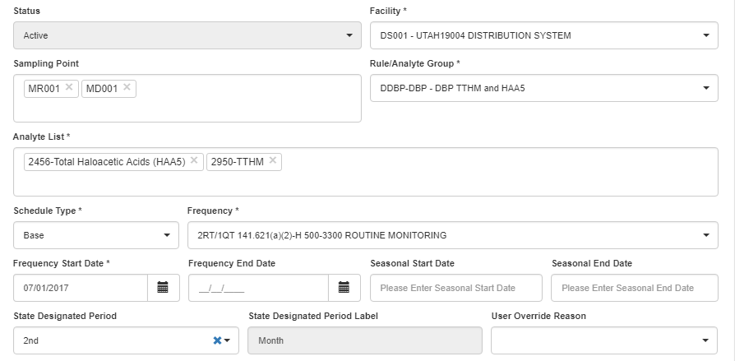

- Enter the following six routine samples that cover three quarters of monitoring.
Sample Type | Sampling  Point | Sample Date | TTHM (2950) Result | HAA5  (2456)  Result | Agency Received Date
Routine | 1st sampling point entered for the MS | 08/14/2017 | 22.4 ug/L | 15.2 ug/L | 09/10/2017
Routine | 2nd sampling point entered for the MS | 08/14/2017 | 35.4 ug/L | 13.2 ug/L | 09/10/2017
Routine | Neither sampling point entered for the MS | 11/13/2017 | 12.8 ug/L | 7.7 ug/L | 11/29/2017
Routine | 2nd sampling point entered for the MS | 11/13/2017 | 18.7 ug/L | 5.8 ug/L | 11/29/2017
Routine | 1st sampling point entered for the MS | 02/12/2018 | 8.7 ug/L | 11.2 ug/L | 03/02/2018
Routine | Neither sampling point entered for the MS | 02/12/2018 | 5.5 ug/L | No detect | 03/02/2018

Expected Outcomes:
  - For the August 2017 period, both TTHM and HAA5 should have two results associated and the Pos/Above MCL Indicator valued with "N."
  - For the November 2017 period, both TTHM and HAA5 should have one result associated, the one collected at the 2nd sampling point, and the Pos/Above MCL Indicator valued with "N."
  - For the February 2018 period, both TTHM and HAA5 should have one result associated, the one collected at the 1st sampling point, and the Pos/Above MCL Indicator valued with "N."
- Run M/R Compliance for the DDBP Rule for the period from 07/01/2017 through 06/30/2018.
Expected Outcomes:
  - A minor monitoring violation (code 27) for both 2950 (TTHM) and 2456 (HAA5) for the compliance period 10/01/2017 to 12/31/2017
  - A minor monitoring violation (code 27) for both 2950 (TTHM) and 2456 (HAA5) for the compliance period 01/01/2018 to 03/31/2018
  - A major monitoring violation (code 27) for both 2950 (TTHM) and 2456 (HAA5) for the compliance period 04/01/2018 to 06/30/2018

End of test

Test Case # 37 - DBP M/R Violation, Every 90 Days Failure

Requirements that Apply
141.132 (b) Monitoring requirements for disinfection byproducts: (1) TTHMs and HAA5: (i) Routine Monitoring…."systems on quarterly monitoring must take sample sets every 90 days at each monitoring location."
Because of the above requirement in the CFR and EPA's application of that requirement, Prime expects TTHM and HAA5 samples to be taken in the same month of each calendar quarter when a system is on quarterly monitoring. For example, if a PWS collects its first quarter samples in January, then Prime will check to see if samples were collected during the first month of subsequent quarters, i.e., April, July and October. If this doesn't occur, then Prime will create a candidate monitoring violation.

Test Description
A community water system (CWS) incurs a monitoring violation for not taking routine distribution TTHM and HAA5 samples "within 90 days" of each other while on quarterly DDBP monitoring.

Test Steps and Outcomes
- Select a community water system that serves a population between 500 and 9,999 and has surface water as its Federal Primary Water Source.
- Confirm that at least one of the active treatment plants for the CWS has the following Treatment: (a) Objective: "D - Disinfection" and (b) Process that involves chlorine (i.e., 401, 403, 421, or 423). If the above treatment does not exist, add the following Objective and Process for at least one of the CWS's treatment plants: "D - Disinfection" and "401-Gaseous Chlorination, Post" (see screenshot - this is needed for the DDBP Rule to apply to the water system in Prime.)
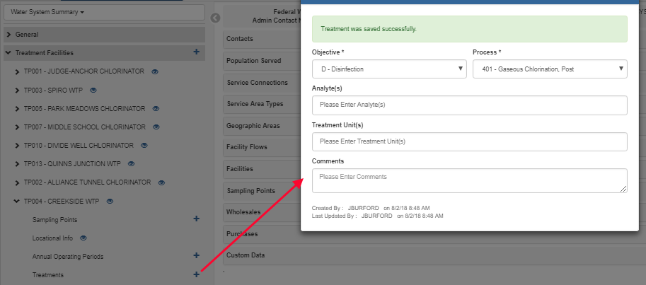

- Enter a "Base" monitoring schedule for DDBP-DBP with analytes "2456-Total Haloacetic Acids (HAA5)" and "2950-TTHM" with a Frequency of "2RT/1QT" for the CWS's distribution system with a Frequency Start Date of "01/01/2017".
Note that, in this test case, the primacy agency did not specify the month of each quarter in which samples should be collected so a State Designated Period has not been entered.

See the following screenshot as an example.
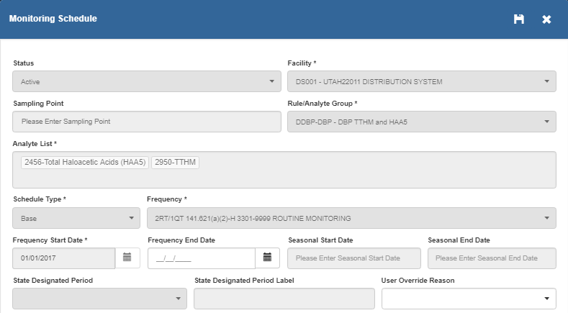

- Enter the following TTHM and HAA5 routine, distribution samples and results for the CWS selected in Step 1. You can use one or more laboratories for the samples.
Sampling Point | Collection Date | Sample Type | Analyte [Code-Name] | Result | Result UOM | Agency Received Date
1 | 1/9/2017 | Routine | 2950-TTHM | 65.3 | ug/L | 1/30/2017
 |  |  | 2456-TOTAL HALOACETIC ACIDS (HAA5) | 25.6 | ug/L | 1/30/2017
2 | 1/9/2017 | Routine | 2950-TTHM | 52.4 | ug/L | 1/30/2017
 |  |  | 2456-TOTAL HALOACETIC ACIDS (HAA5) | 18.7 | ug/L | 1/30/2017
1 | 4/10/2017 | Routine | 2950-TTHM | 58.7 | ug/L | 5/1/2017
 |  |  | 2456-TOTAL HALOACETIC ACIDS (HAA5) | 29.4 | ug/L | 5/1/2017
2 | 4/10/2017 | Routine | 2950-TTHM | 48.6 | ug/L | 5/1/2017
 |  |  | 2456-TOTAL HALOACETIC ACIDS (HAA5) | 21.5 | ug/L | 5/1/2017
1 | 9/18/2017 | Routine | 2950-TTHM | 72.6 | ug/L | 10/6/2017
 |  |  | 2456-TOTAL HALOACETIC ACIDS (HAA5) | 28.4 | ug/L | 10/6/2017
2 | 9/18/2017 | Routine | 2950-TTHM | 54.3 | ug/L | 10/6/2017
 |  |  | 2456-TOTAL HALOACETIC ACIDS (HAA5) | 24.8 | ug/L | 10/6/2017
1 | 10/9/2017 | Routine | 2950-TTHM | 59.4 | ug/L | 10/30/2017
 |  |  | 2456-TOTAL HALOACETIC ACIDS (HAA5) | 33.7 | ug/L | 10/30/2017
2 | 10/9/2017 | Routine | 2950-TTHM | 46.7 | ug/L | 10/30/2017
 |  |  | 2456-TOTAL HALOACETIC ACIDS (HAA5) | 21.8 | ug/L | 10/30/2017

Expected Outcomes:
  - The sample results collected in January, April, and October are associated with their appropriate periods in the monitoring schedule (i.e., the first, second, and fourth calendar quarters).
  - The sample results collected in September are not associated with the third calendar quarter period because these samples exceeded 90 days from the previous sample dates and cannot be used for compliance with the DBP rule.

- Run M/R Compliance for DDBP for calendar year 2017 using the Monitoring and Reporting Compliance form on the Monitoring Schedule page.
Expected Outcomes:
- There should be two candidate 27-MONITORING, ROUTINE (DBP) violation for monitoring period 7/1/2017 to 9/30/2017, one for 2950-TTHM and the other for 2456-TOTAL HALOACETIC ACIDS (HAA5). (Select the Violations from the task picker to confirm.)

End of test

Test Case # 39 - Failure to Address a GWR Deficiency

Test Description
Three significant deficiencies were identified during a sanitary survey at a community water system (CWS) with groundwater as its primary source. The CWS addressed one of the deficiencies on time; addressed the second deficiency later than required; and failed to address the third significant deficiency. The BRE should create two candidate code 45 violations that both reference the code for GWR.

Test Steps and Outcomes
- Select an active community, groundwater system.
For these selected systems, enter a complete sanitary survey including three significant deficiencies and deficiency plans by selecting "Site Visit" in the task picker. Follow the steps below and use the values as indicated in the screen shots if not otherwise provided.
Note that, in a later release of Prime, a Standard Response capability will be added to more rapidly create deficiency plans.
- Enter a Site Visit. Use the following values:
- Primary Reason: Sanitary Survey, Complete
- Visiting Agency Type: Any (e.g., State)
- Visit Date: 3/27/2018
- WS Notification Date: 4/5/2018
- Enter the following three deficiencies for the Site Visit as indicated in the screen shots below. Notice that the above dates carry-forward to the corresponding date fields for each deficiency. Leave these as defaulted. Notice also that, at this time, Deficiency Type records have not been uploaded and so you describe the deficiency in the Comments field.
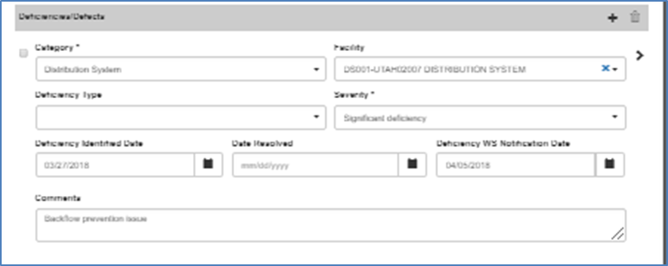

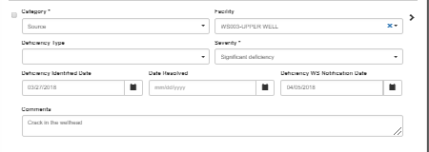
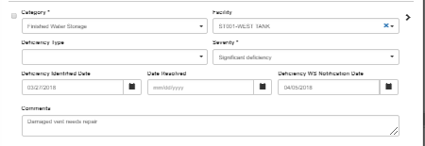
- For each of the three significant deficiencies, enter the following Deficiency Plan:
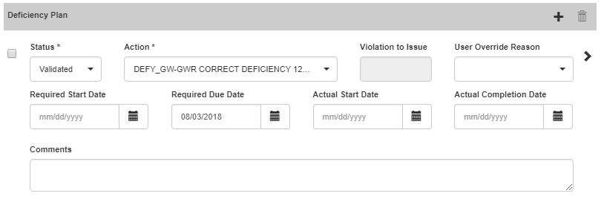

- Enter an Actual Completion Date for two of the deficiency plans as follows:
- Select "Deficiencies" in the task picker.
- Locate the two deficiencies listed below using the sorting features if helpful, e.g., sort ascending on Date Identified) and enter the following Actual Completion Dates.
ID | Actual Completion Date
Distribution System-DS001--3/27/18 | 08/03/2018
Finished Water Storage-ST001--3/27/18 | 08/08/2018

- Run Scheduled Activity Compliance
Run Scheduled Activity Compliance by selecting "Scheduled Activities" in the Task picker.
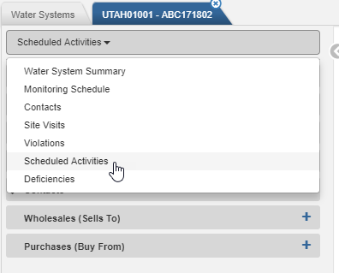

On the resulting Scheduled Activities landing page, expand the Schedule Activity Compliance area and then enter the following criteria:
Due Date Range: 08/03/2018 to 08/03/2018
Category: Deficiency
Expected Outcomes:
  - Two candidate violations with the values indicated below should be created:
    - Violation one:
      - Facility ID: Blank or the finished water storage referenced in the deficiency
      - Rule/Analyte Group: GWR-NPDWR
      - Violation: 45-FAILURE ADDRESS DEFICIENCY (GWR)
      - Contaminant Code: 0700-GROUNDWATER RULE
      - Compliance Period Begin Date: 08/04/2018
      - Compliance Period End Date: Null
    - Violation two:
      - Facility ID: Blank or the source water facility referenced in the deficiency
      - Rule/Analyte Group: GWR-NPDWR
      - Violation: 45-FAILURE ADDRESS DEFICIENCY (GWR)
      - Contaminant Code: 0700-GROUNDWATER RULE
      - Compliance Period Begin Date: 08/04/2018
      - Compliance Period End Date: Null

End of test

Test Case # 40 - Display Originating Result for RP, TG, and CO MS

Test Description
A community groundwater system has a positive RTCR routine total coliform result and a nitrate result above 10 mg/L. Prime automatically creates a candidate RTCR repeat monitoring schedule (MS), one or more candidate GWR triggered MS, and a candidate nitrate confirmation MS. Each of the candidate MSs displays the result that originated (i.e., triggered) the candidate MS.

Test Steps and Outcomes
- Select a community water system (CWS) that serves a population of less than 1,000 people and has one or more active ground water sources.
- Enter an RTCR routine MS that requires 1 routine per month and starts on 1/1/2018.
- Enter a quarterly nitrate MS for one of the CWS's entry point facilities that starts on 1/1/2018.
- Enter the following samples and results.
Sample | Facility | Sampling  Point | Collection  Date | Sample Type | Analyte | Result | Analysis  Completed  Date | Agency Received Date
1 | DS with the RTCR MS | Any | 7/16/2018 | Routine | 3100-Total Coliform | Present | 7/19/2018 | 7/20/2018
 |  |  |  |  | 3014-E. Coli | Absent | 7/19/2018 | 7/20/2018
2 | EP facility with the NO3 MS | Any | 7/9/2018 | Routine | 1040-Nitrate | 10.8 mg/L | 7/18/2018 | 7/20/2018

Expected Outcomes: the BRE generates the following monitoring schedules:
- A candidate RTCR repeat MS
- One or more candidate GWR triggered MSs
- A candidate confirmation MS
- Open each candidate repeat, triggered, and confirmation MS and confirm that the sample result that triggered the candidate MS is displayed on the Monitoring Schedule form.
It should look similar to the following.
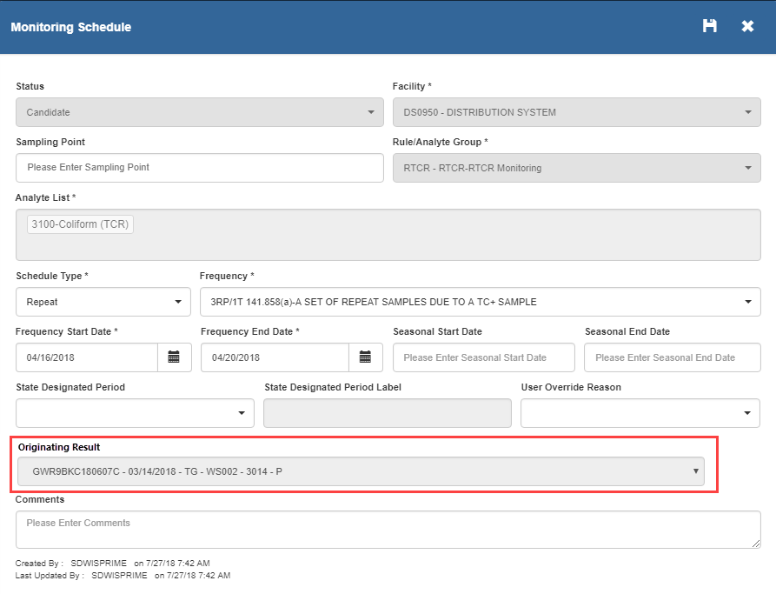

End of test

