Government Employee Instructions for Accessing the PFAS Analytic Tools via ECHO Gov
(9.30.20 Version)

The following instructions are for government users (excluding EPA employees) that would like to access the PFAS Analytic Tools via the Enforcement and Compliance History Online (ECHO) Gov website. EPA employees may access the tools in navigation path below, but can use single-sign on and do not have to create an account.

Access to the PFAS Analytic Tools Version 2.0 is via log-in at ECHO Gov (if you don’t have an account, you can create one from ECHO at https://echo.epa.gov/user/register). You may list barrette.michael@epa.gov (US EPA OECA) as your sponsor.

After you submit the request, it may take up to 24 hours for you to be activated. When you log in, the initial access process to the PFAS tools will require two attempts. While the first fails to gain entry, it creates your Qlik account on your behalf. Then all future attempts to enter should be successful.

Navigate to the tool in the following way… echo.epa.gov > log in > click “Analyze Trends” > click “PFAS Analytic Tools” from the Data Visualization Gallery (see screen capture) > you will be in the PFAS Navigation Center which tells you about the tool and data sets > Click on “Open PFAS Analytic Tools” to access the data. There are many improvements to the tool described in the release notes which are also summarized below. For technical log in problems – please contact Tamulonis.charles@epa.gov.

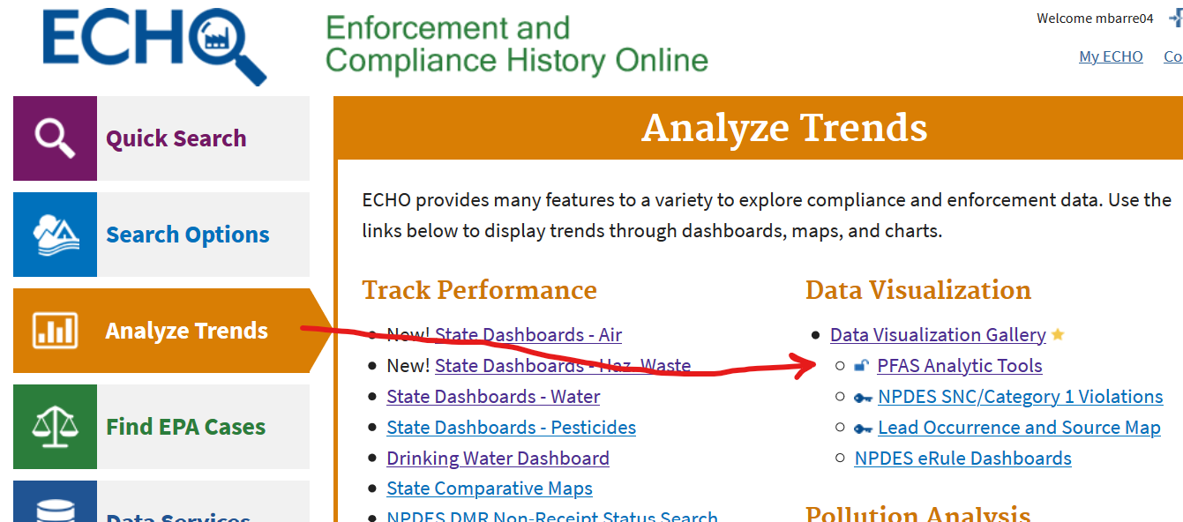

PFAS Analytic Tools - Version 2.0 Release Notes (ECHO Gov)

  - EPA released Version 2.0 to EPA, States and other government users in January 2020.
  - Version 2.0 has a better look and feel and improves the user experience in the following ways.
    - Presenting data layers as tabs across the top of the screen
    - Relocating the filters to the left side of the page and posting selected filters at the bottom.
    - All maps and graphs can be resized to full screen.
    - Reducing clutter of Qlik-specific controls on maps and charts, which can be confusing, by creating an intuitive user interface that interacts with Qlik
    - Data can be downloaded directly from the tool using the download icon.
    - All data sets have been updated.
  - Version 2 includes a new “industry sector” tab that provides a listing of facilities that are in industries known to handle or use PFAS chemicals.
    - The data is from ECHO and includes facilities regulated under CWA, CAA, RCRA and SDWA.
    - The SIC and NAICS codes used combined from lists maintained by EPA program offices and one state (Minnesota).
    - Currently the industry sector locations cannot be combined in the integrated map, but we hope to add this feature in the future.
  - EPA has also updated the “Places of Interest” tab.
    - In Version 1.0, there were limited data primarily for Superfund sites.
    - In Version 2.0, EPA has adopted a new data model which provides a greater degree of detail about locations where EPA is involved in PFAS-related activities. This layer is still under development.
    - EPA is working with state associations to eventually add state places of interest to this data layer.
  - Authorized users can access the PFAS Analytic Tools via the following pathway – go to echo.epa.gov > log in > click “Analyze Trends” > click “Data Visualization Gallery” > select PFAS Analytic Tools and Navigation Center > click on PFAS Analytic Tools from the Navigation Center.

